**HACKHATHON DAY 5 TESTING, ERROR HANDLING, AND BACKEND INTEGRATION REFINMENT**

**Step 1: Functional testing**



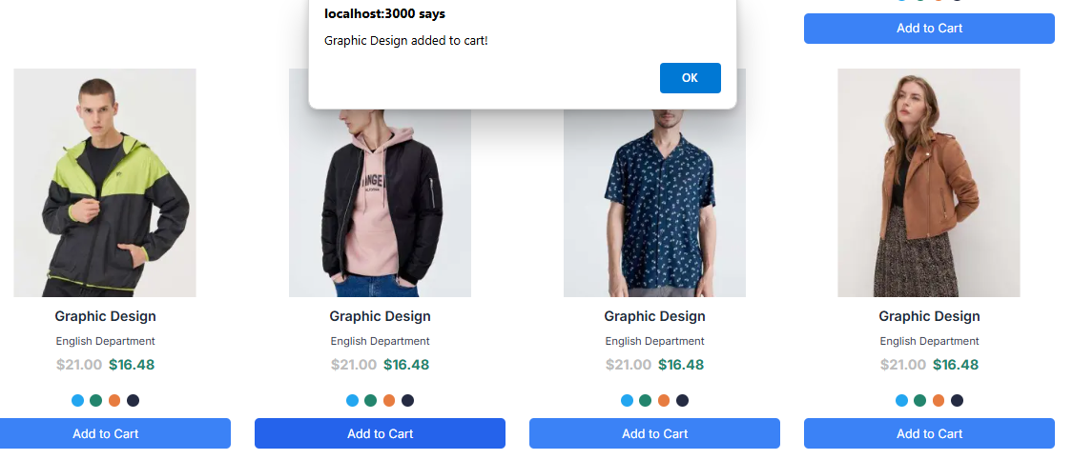

**Step 2: Error Handling**

**Step 3: Postman API**

[template6-six.vercel.app/api/products](https://template6-six.vercel.app/api/products)

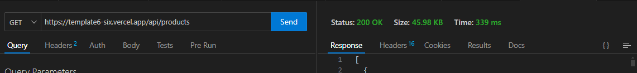

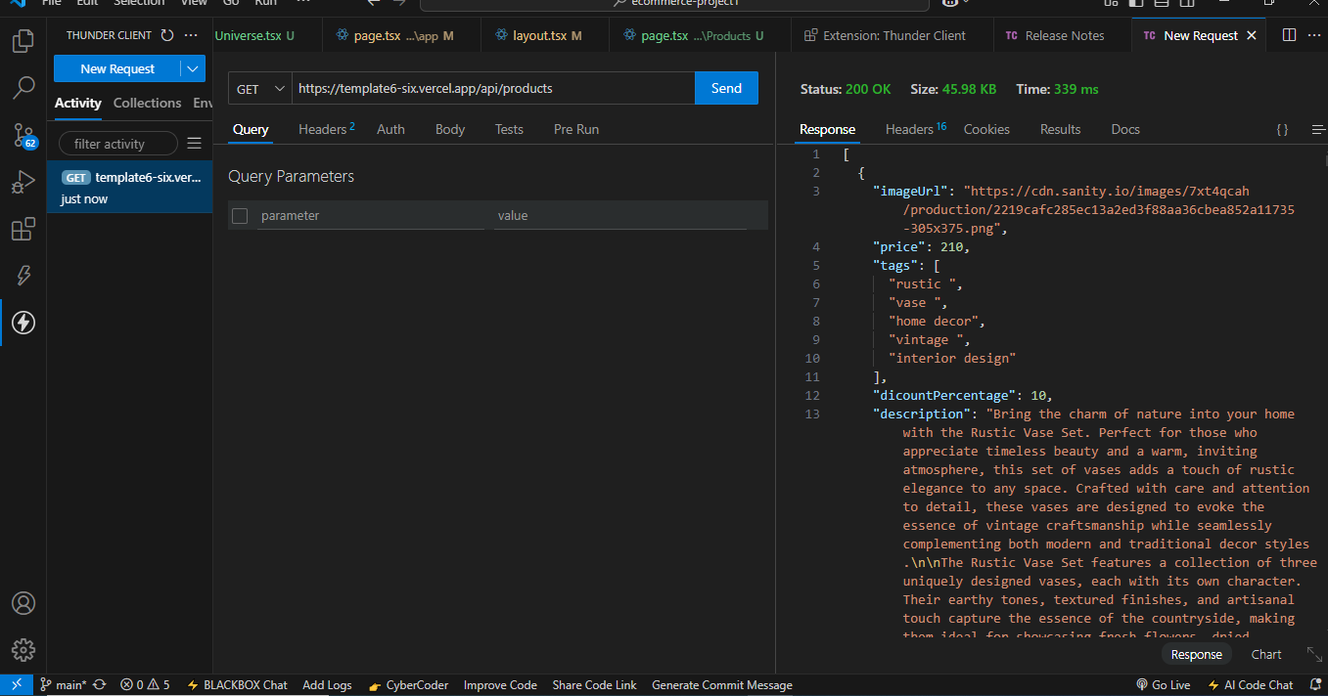

**Responsive:**

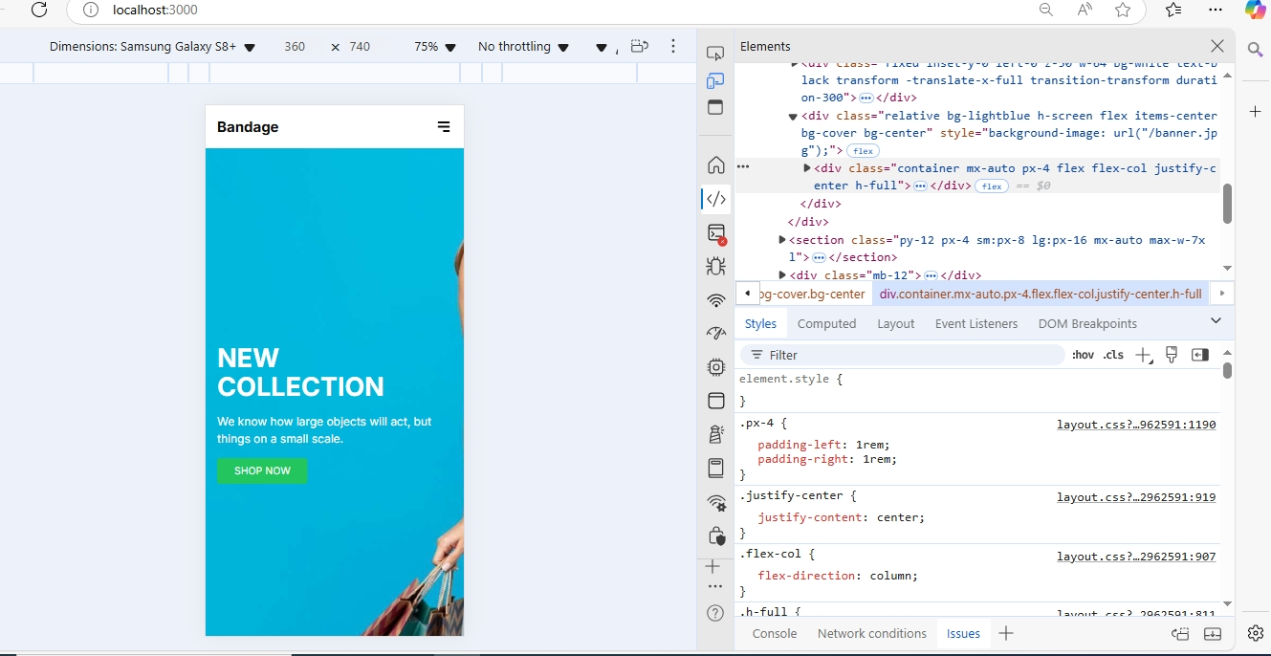

**Step 4: Performance Optimization**

npm install –g lighthouse

lighthouse <http://localhost:3000> –view

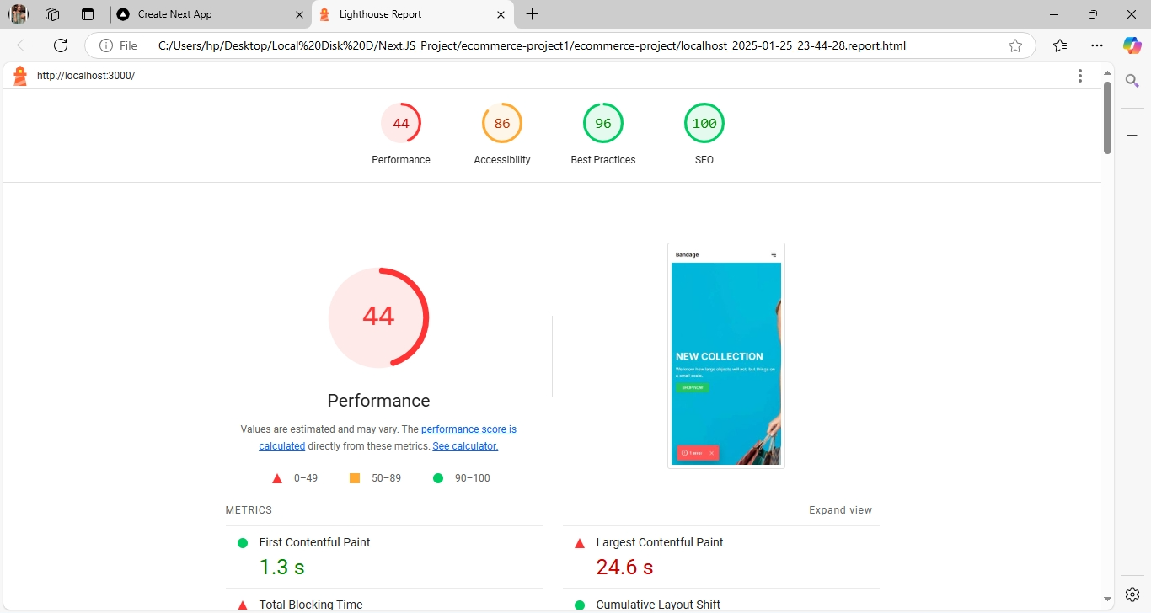

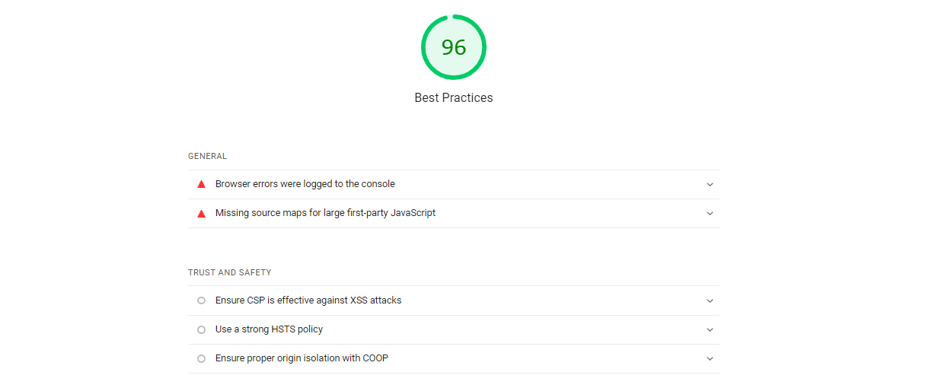

Trust and Safety

Ensure CSP is effective against XSS attacks

|  |  |  |
| --- | --- | --- |
|  |  |  |

Use a strong HSTS policy

|  |  |  |
| --- | --- | --- |
|  |  |  |

Ensure proper origin isolation with COOP

**Developer Recourses:**

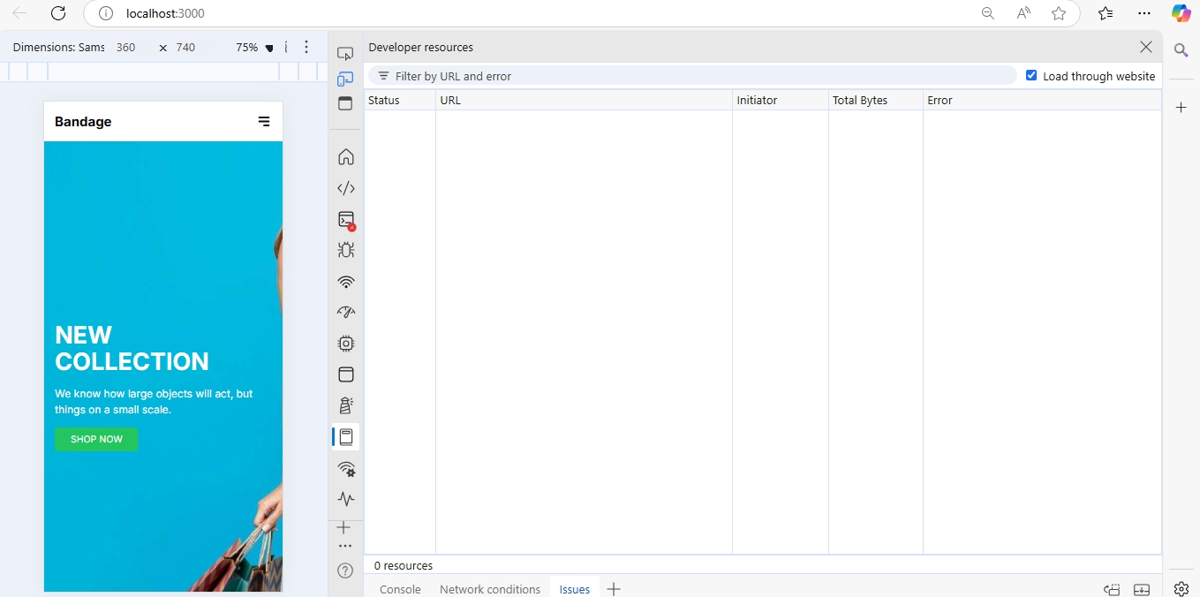

|  |  |  |
| --- | --- | --- |
|  |  |  |

**Performance Monitor:**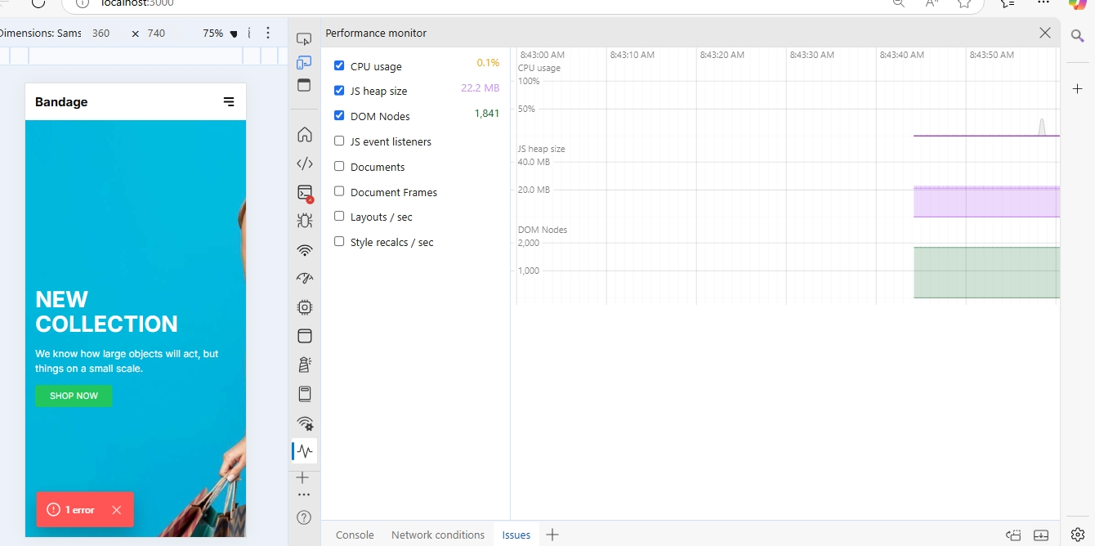

**Security:**

